Community Lifelines Toolkit: A Presenter’s Guide
This document is intended for any individual who is planning to deliver the Lifelines Toolkit as a presentation. It follows the order of each slide in the presentation and provides corresponding facilitation notes. The guide is not intended to be a script but merely suggested notes for how to supplement the information in the Toolkit and anticipate questions.
# | Slide Title & Image | Notes
Introduction & Organization
1 | Title Slide  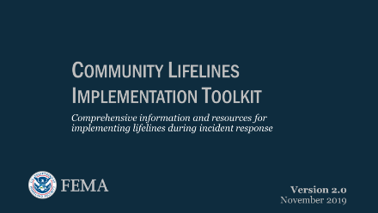 | - Thank you for allowing time on your agenda to discuss community lifelines.  - Today I will be presenting our Lifelines Toolkit, Version 2.1.  - This Toolkit was created to provide unified guidance and templates on what the community lifelines are and how they can be implemented within response operations.  - The Toolkit serves as a resource for those partners who wish to implement lifelines and for those who want to gain a better understanding of them.
2 | Organization  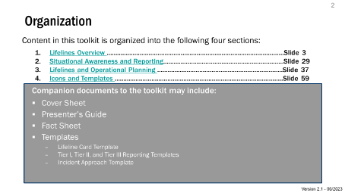 | - This presentation has been set up in a modular format with four distinct sections.  - Section I provides a Lifelines overview that covers definitions and how each lifeline is analyzed and assessed.  Note: At the moment, lifeline implementation is primarily focused on FEMA implementation, though some states have adopted and are using the construct.  - Section II elaborates on the different situational awareness and reporting tools used with the lifelines construct.  - Note: These tools and processes have been updated to focus more on community impact, rather than stabilization. Additional information will be in the following slides.  - Section III is focused on lifelines and operational planning.  - Finally, Section IV covers the lifeline iconography, with an Icon Library and color palette, as well as relevant templates.  - As lifeline implementation further matures, we will be adding to the Toolkit and refining both the guidance and materials.  - We will share copies of this presentation and the accompanying Toolkit files (templates, fact sheets, and cover page) with anyone who requests it.  - Note: due to recent updates to this presentation, to include adding an eighth lifeline, the complete toolkit is under revision. Many of the toolkit files have been updated at this time, but others will need to be updated in the coming months.
Section I: Lifelines Overview
3 | Section I: Lifelines Overview  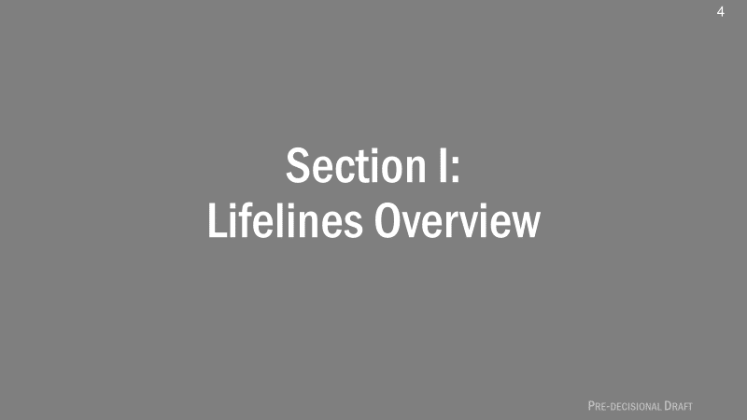 | - This section is where we will spend the most time reviewing the lifelines construct and understanding how it should be applied to incident operations.
4 | Incorporating Community Lifelines into Response  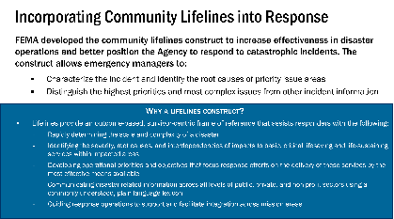 | - FEMA developed the community lifelines construct to increase effectiveness in disaster operations and better position the Agency to respond to catastrophic scenarios. The construct allows FEMA to:  - Characterize the incident and identify the root causes of priority issue areas  - Distinguish the highest priorities and most complex issues from other incident information  - As noted on the slide, the lifeline construct can help responders and decision-makers rapidly determine the scope, complexity, and interdependent impacts of an incident.  Cover remaining information on slide and pause for questions or discussion.
5 | Toolkit 2.1  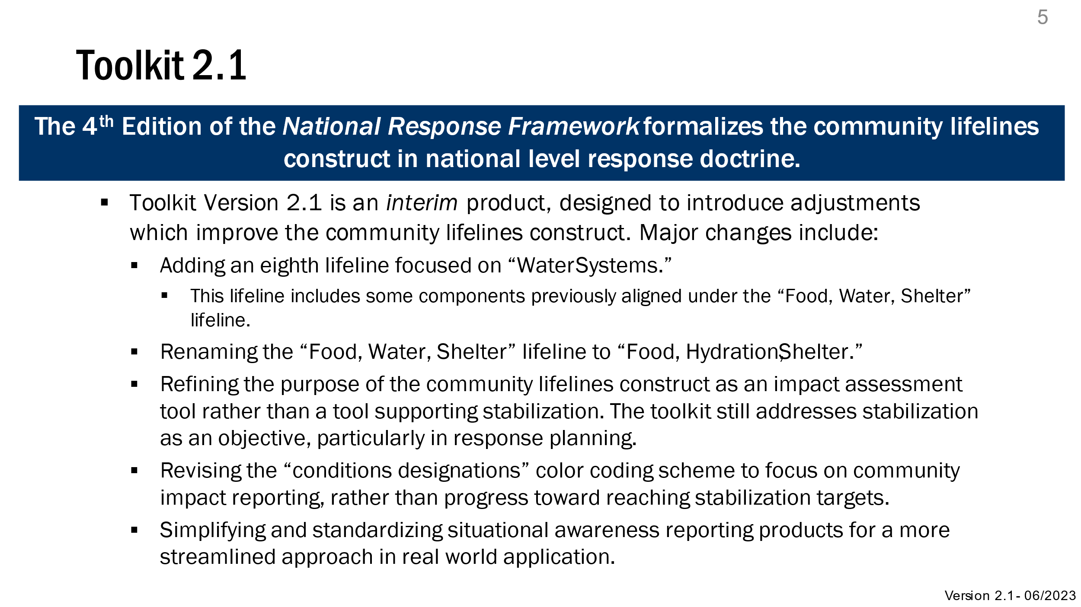 | - 4th Edition of the National Response Framework formalizes the lifelines construct in national level response doctrine.  - Toolkit Version 2.1 reflects refinements and improvements to the lifelines construct. Primarily, these refinements have been designed to adjust and improve the construct and it’s definition.  - Major Changes:  - Added an eighth lifeline focused on “Water Systems.”  - Renamed the “Food, Water, Shelter” Lifeline as “Food, Hydration, Shelter.”  - Refined the purpose of the construct as an impact assessment tool, rather than one supporting stabilization. Though stabilization is still addressed later in this presentation.  - Updated the “conditions designations” color coding scheme to focus on community impact reporting, rather than progress towards stabilization targets.  - Simplified and standardized situational awareness reporting products for a more streamlined approach in real world application.
6 | Evolution of the Community Lifelines Concept  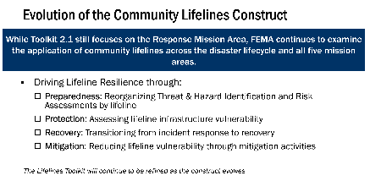 | - While Toolkit 2.1 still focuses on the Response Mission Area, FEMA continues to examine the application of community lifelines across the disaster lifecycle and all five mission areas.  - Driving Lifeline Resilience through:  - Preparedness: Reorganizing Threat & Hazard Identification and Risk Assessments by lifeline  - Protection: Assessing lifeline infrastructure vulnerability  - Recovery: Transitioning from incident response to recovery  - Mitigation: Reducing lifeline vulnerability through mitigation activities
7 | Lifelines, Core Capabilities, ESFs  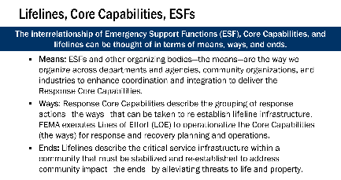 | - The interrelationship of Emergency Support Functions (ESF), Core Capabilities, and lifelines can be thought of in terms of means, ways, and ends:  - Means: ESFs and other organizing bodies—the means—are the way we organize across departments and agencies, community organizations, and industry to enhance coordination and integration to deliver the Response Core Capabilities  - Ways: Response Core Capabilities describe the grouping of response actions—the ways—that can be taken to re-establish lifeline infrastructure. FEMA executes Lines of Effort (LOE) to operationalize the Core Capabilities (the ways) for response and recovery planning and operations.  - Ends: Lifelines describe the critical service infrastructure within a community that must be stabilized and re-established to address community impact—the ends—by alleviating threats to life and property
8 | Community Lifeline Implementation  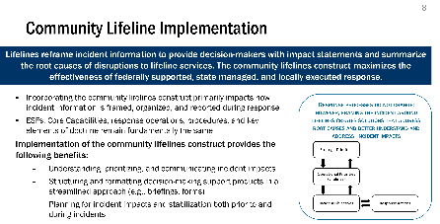 | - Lifelines reframe incident information to provide decision-makers with impact statements and summarize the root of disruptions to lifeline services. The community lifelines construct maximizes the effectiveness of federally supported, state managed, and locally executed response.  - Incorporating the community lifelines construct primarily impacts how incident information is framed, organized and reported during response.  - Emergency Support Functions (ESF), Core Capabilities, response operations, procedures, and key elements of doctrine remain fundamentally the same.  - Implementation of the community lifelines construct provides the following benefits:  - Understanding, prioritizing, and communicating incident impacts  - Structuring and formatting decision-making support products in a streamlined approach (e.g., briefings, forms)  - Planning for incident impacts and stabilization both prior to and during incidents.
9 | Community Impact  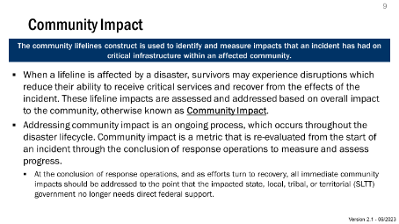 | - The community lifelines construct is used to identify and measure impacts that an incident has had on critical infrastructure within an affected community.  - When a lifeline is affected by a disaster, survivors may experience disruptions which reduce their ability to receive critical services and recover from the effects of the incident. These lifeline impacts are assessed and addressed based on overall impact to the community, otherwise known as community impact.  - Addressing community impact is an ongoing process, which occurs throughout the disaster lifecycle. Community impact is a metric that is re-evaluated from the start of an incident through the conclusion of response operations to measure and assess progress.  - At the conclusion of response operations, and as efforts turn to recovery, all immediate community impacts should be addressed to the point that the impacted state, local, tribal, or territorial (SLTT) government no longer needs federal support.
10 | Community Lifelines Defined  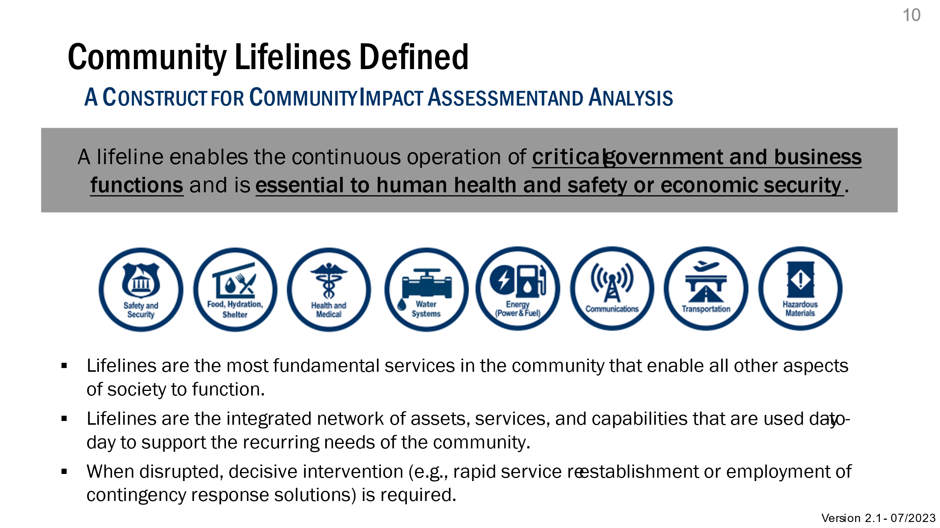 | - The definition of lifelines is provided on this slide, there are eight in total as represented by the icons:  - Safety and Security  - Food, Hydration, and Shelter  - Health and Medical  - Water Systems  - Energy  - Communications  - Transportation  - Hazardous Material  - The lifelines help characterize an incident, i.e., what is happening and why it is important.  - The lifelines also represent “buckets” of the most critical capabilities and services provided to citizens and survivors, regardless of whether they are provided by the public, private, or non-profit sectors.
11 | Deconstructing Community Lifelines  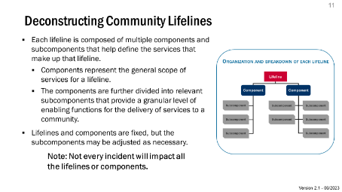 | - Each lifeline is comprised of multiple components and subcomponents that help define the services that make up that lifeline.  - Components represent the general scope of services for a lifeline.  - Components are further divided into relevant subcomponents that provide a granular level of enabling functions for the delivery of services to a community.  - Lifelines and Components are fixed, but the subcomponents may be adjusted as necessary.  - Note: Not every incident will impact all of the lifelines or components.
12 | Community Lifeline Construct  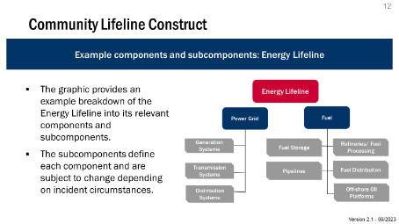 | - Subcomponents will vary from incident to incident and may even change during the lifespan of a single incident.  - The subcomponents on the subsequent slides are a representative list of possible subcomponents and is not comprehensive.  - The graphic shows an example of the lifeline construct showing the energy lifeline, its two components, and some subcomponents relevant to this example incident.  - The lifeline construct (Lifeline Component Subcomponent) is purely organizational and is designed to help responders characterize the incident and organize response to re-establish essential services and eliminate community impact.
13 | Community Lifeline Components  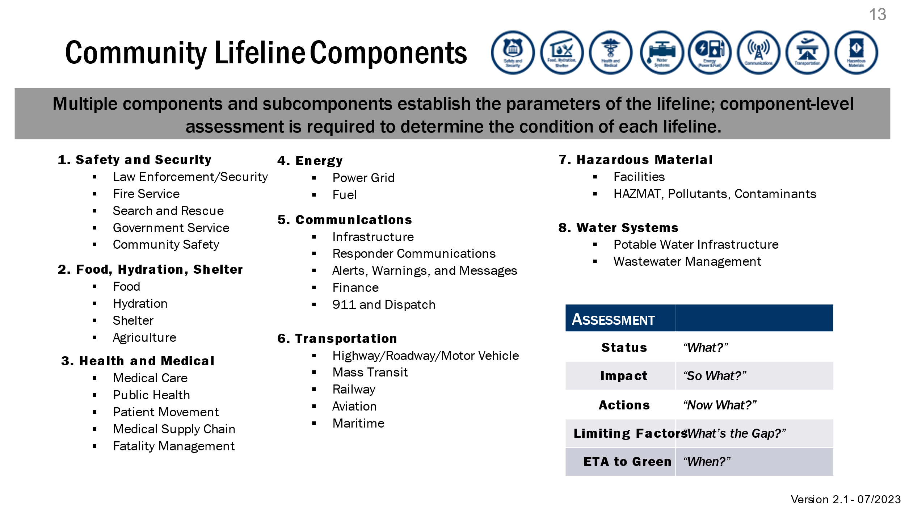 | - Lifeline components provide the scope of and parameters for what each lifeline covers.  - This is a fluid construct, but, for reporting purposes and organization, this is how the components have been “bucketed” across the lifelines.  - Subsequent slides will provide the subcomponents for each component.  - Note: the lifeline icons at the top of the slide as well as the snapshot within the table that identifies key information each participant should keep in mind when reviewing each component within a response context: “Status, Impact, Actions, Limiting Factors, and ETA to Green.”
14 | Safety and Security  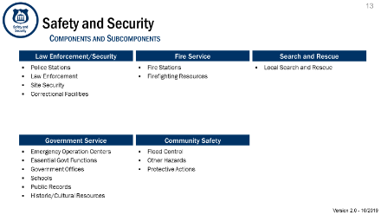 | - This slide covers the Safety and Security lifeline, along with its 5 component areas and relevant subcomponents.  - Law Enforcement/Security  - Fire Service  - Search and Rescue  - Government Service  - Community Safety  - This lifeline covers responder and survivor safety and the continuity of government (including basic services, firefighting, and law enforcement).  - Note: Additional subcomponents and components can be added to this lifeline, but at minimum this list should provide a necessary baseline for further analysis and assessment.
15 | Food, Hydration, Shelter  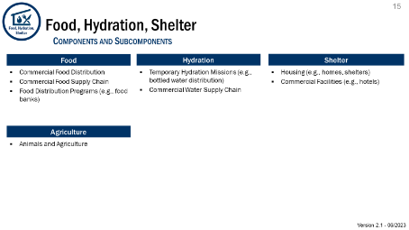 | - This slide covers the Food, Hydration, and Shelter lifeline, along with its 4 component areas and relevant subcomponents.  - Food  - Hydration  - Shelter  - Agriculture  - This lifeline covers not only traditional feeding and hydration services, which are routinely paired with sheltering (hence the grouping of components in this lifeline), but it also covers agricultural infrastructure that is closely tied.  - Note: Additional subcomponents and components can be added to this lifeline, but at minimum this list should provide a necessary baseline for further analysis and assessment.
16 | Health and Medical  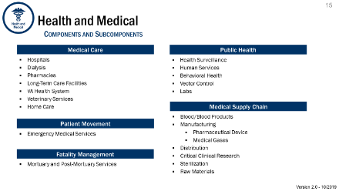 | - This slide covers the Health and Medical lifeline, along with its 5 component areas and relevant subcomponents.  - Medical Care  - Patient Movement  - Fatality Management  - Public Health  - Medical Supply Chain  - This lifeline covers all aspects of medical services required during an incident, including survivor care, fatality management, public health, and the medical supply chain.  - Note: Additional subcomponents and components can be added to this lifeline, but at minimum this list should provide a necessary baseline for further analysis and assessment.
17 | Water Systems  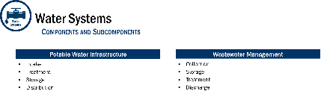 | - This slide covers the Water Systems lifeline, along with its 2 component areas and relevant subcomponents.  - Potable Water Infrastructure  - Wastewater Management  - This lifeline covers all water movements related to intake, treatment, storage, collection, distribution, and discharge.  - Note: This is a new lifeline and will continue to be refined over time.  - Note: Additional subcomponents and components can be added to this lifeline, but at minimum this list should provide a necessary baseline for further analysis and assessment.
18 | Energy  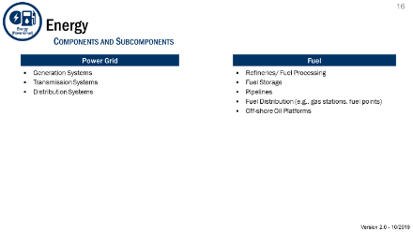 | - This slide covers the Energy lifeline, along with its 2 component areas and relevant subcomponents.  - Power Grid  - Fuel  - This lifeline is focused on only electricity and fuel, which are both essential to a successful response operation.  - Note: Additional subcomponents and components can be added to this lifeline, but at minimum this list should provide a necessary baseline for further analysis and assessment.
19 | Communications  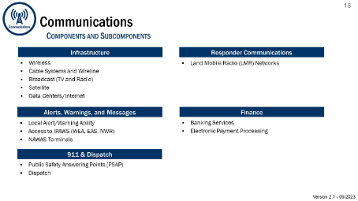 | - This slide covers the Communications lifeline, along with its 5 component areas and relevant subcomponents.  - Infrastructure  - Alerts, Warnings, and Messages  - 911 and Dispatch  - Responder Communications  - Finance  - This lifeline covers all types of communications necessary to effectively respond to and help survivors, in addition to banking and electronic payment needs.  - Note: Additional subcomponents and components can be added to this lifeline, but at minimum this list should provide a necessary baseline for further analysis and assessment.
20 | Transportation  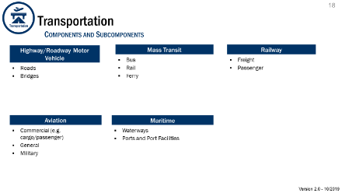 | - This slide covers the Transportation lifeline, along with its 5 component areas and relevant subcomponents.  - Highway/Roadway Motor Vehicle  - Mass Transit  - Railway  - Aviation  - Maritime  - This lifeline covers all forms of transportation of people and resources to and from the incident.  - Note: Additional subcomponents and components can be added to this lifeline, but at minimum this list should provide a necessary baseline for further analysis and assessment.
21 | Hazardous Materials  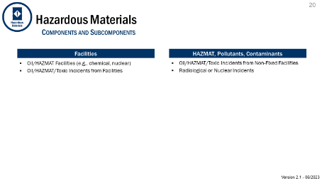 | - This slide covers the Hazardous Material lifeline, along with its 2 component areas and relevant subcomponents.  - Facilities  - HAZMAT, Pollutants, Contaminants  - This lifeline covers the management (including containment and removal) of all hazardous materials.  - Note: Some folks may notice that this lifeline was initially titled “Hazardous Waste”, but the title has been changed to more accurately reflect the lifeline components and how it is being applied (i.e., “Hazardous Material” covers a much broader scope than simply “Hazardous Waste”).  - Note: Additional subcomponents and components can be added to this lifeline, but at minimum this list should provide a necessary baseline for further analysis and assessment.
22 | Determining Lifeline Condition  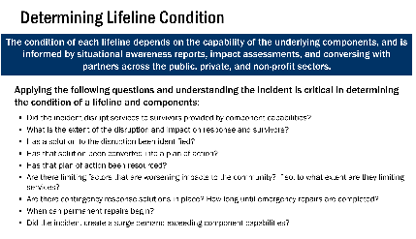 | - This slide introduces the topic of determining lifeline condition. Slides 31-35 will discuss aspects of determining condition and provide examples.  Encourage participants to hold their questions as they may be answered shortly on subsequent slides.  - The list of questions will be useful in determining lifeline impacts, but it is not a comprehensive list. Response personnel should be empowered to use their judgement (and communicate their rationale) when determining condition.  - Lifeline analysis can be conducted at all levels of response (incident management or support); however, due to the importance of lifeline condition in guiding operations, leadership should sign off on all determinations.  - The answers to these questions come from information provided by responders in the field. To the greatest extent possible, lifeline condition determinations should be driven by the ground truth.
23 | Analyzing Components  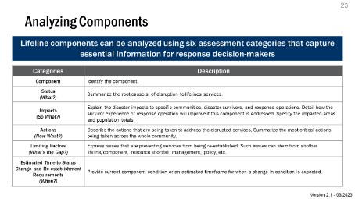 | - Lifelines are assessed by analyzing their individual components, where relevant.  - This analysis covers 6 categories of information:  - Component  - Status  - Impacts  - Actions  - Limiting Factors  - Estimated Time to Condition Change & Re-establishment Requirements  - Responders should analyze components to the best of their knowledge and communicate the reliability of the information.  - This can be challenging immediately after an incident occurs since it may be too early to determine certain categories of information (e.g., estimated time to re-establishment).
24 | Example Component Analysis  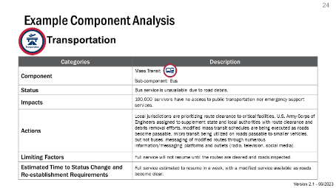 | - This example provides a component analysis from a real-world incident.  - It illustrates how each category may be completed with relevant information.  - Note: more detail is better; this example merely provides a “bare-bones” approach to the analysis.
25 | Colors Indicate Lifeline or Component Condition  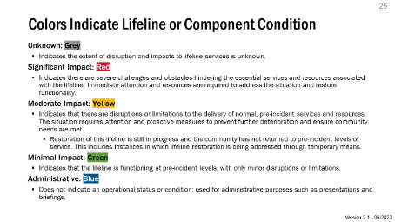 | - There are two main factors that comprise and differentiate between the color definitions.  - These two factors include:  - Scope of impacts from disruptions; and  - Implementation of a resourced solution.  - Note: To account for the change in lifelines to focus more on community impact rather than stabilization efforts, the color-coding scheme has been updated. This update focuses the user on assessing the overall impact and ultimately addressing that impact completely, rather than the actions needed to stabilize that lifeline.  - Note: There is likely to be different perspectives and interpretations between FEMA and State partners as to the significance of an impact on a lifeline. As such, responders should remember that the lifelines construct is just as much about qualifying impacts as it is interpreting them.
26 | Assigning a Condition  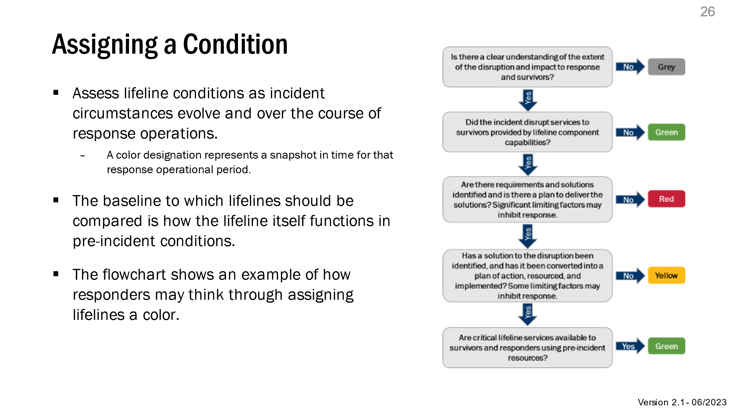 | - Lifeline conditions are assigned iteratively and represent only a snapshot in time for that response operational period.  - The flow chart provides an example that covers some of the key differentiating factors between assigning a “grey,” “red,” “yellow,” or “green” condition.  - This is a simplified way to think through available incident information.
27 | Example Condition Designations  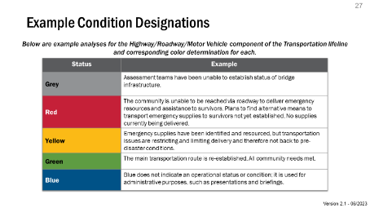 | - The example on this slide provides example scenarios where the highway/roadway/motor vehicle component of the Transportation Lifeline would be assessed at each condition:  - Grey: Unknown  - Red: Significant Impact  - Yellow: Moderate Impact  - Green: Minimal Impact  - Blue: Administrative
28 | FEMA’s Implementation of Community Lifelines  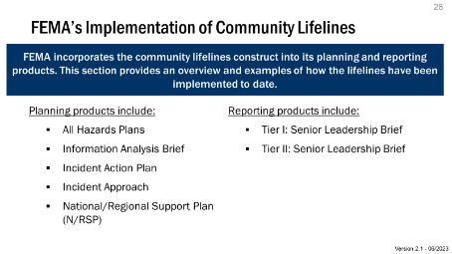 | - The next two sections describe in more detail how lifelines can be applied for situational awareness reporting and operational planning.  - Almost all substantive additions of the lifeline construct have been to reporting products or processes.  - The subsequent slides will provide more detail.  - Note: the list of products on the slide include both HQ and Field products.  - Note: The National Support Plan has also been updated to include community lifelines. This is merely provided for situational awareness since the NSP is primarily a national Incident Support (and not Incident Management) product.  - Note: Some of these products may still be under revision as we add the eighth lifeline and reframe the construct around community impact.
Section II: Situational Awareness and Reporting
29 | Section II: Situational Awareness and Reporting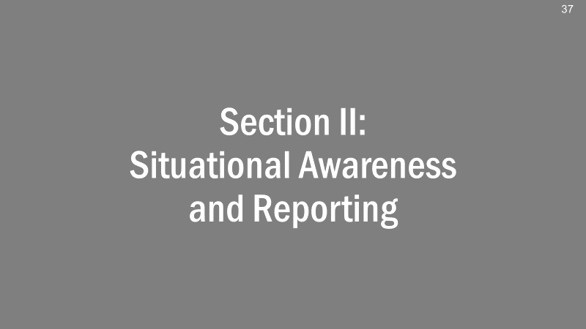 | - This section covers lifeline situational awareness and reporting.  - Note: The situational awareness tools and reporting mechanisms FEMA uses are being updated to better integrate the lifelines construct.  - Note: Due to changes to the standardized reporting construct so that reports focus more on impact, this section is being presented prior to the section on planning.
30 | FEMA Standardized Situation Reporting Construct  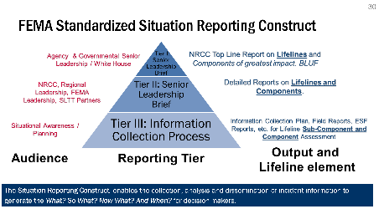 | - Replacing the four-tier Senior Leadership Briefing system is a new, three-tier reporting structure.  - This new Situation Reporting Construct enables the collection, analysis and dissemination of incident information to generate the What? So What? Now What? And When? for decision makers. However, each operational level has a different reporting mechanism they use to relay pertinent information.  - At the headquarters level, the NRCC reports to senior leadership in the government with top level information on each lifeline.  - At the regional level, the RRCC, SLTT governments, and other personnel in the field provide detailed reports on lifelines and components to NRCC, regional, and other FEMA leadership, as well as SLTT partners.,  - Within the field, personnel conduct the information collection process to gather information and conduct assessments. This is relayed to information gatherers and planners.
31 | Lifeline Integrated Reporting Process  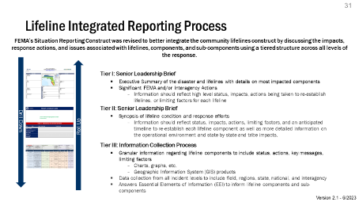 | - Again, this revision to standardize FEMA’s reporting construct was designed to better integrate community lifelines and discuss the impacts, response actions, and issues associated with lifelines, components, and sub-components using a tiered structure across all levels of the response.  - This slide contains more information on all three tiers of the reporting process along with additional information and photographic examples.
32 | Tier I: Senior Leadership Brief  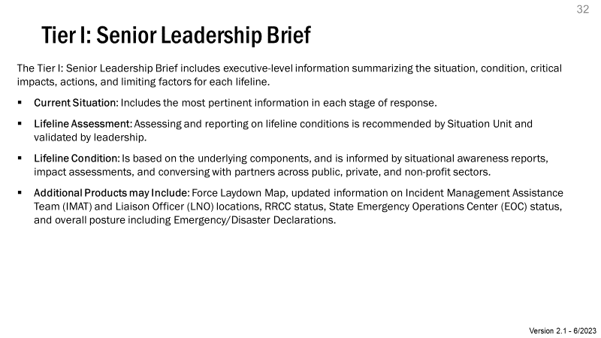 | - The Tier I: Senior Leadership Brief includes executive-level information summarizing the situation, condition, critical impacts, actions, and limiting factors for each lifeline.
33 | Senior Leadership Brief Example  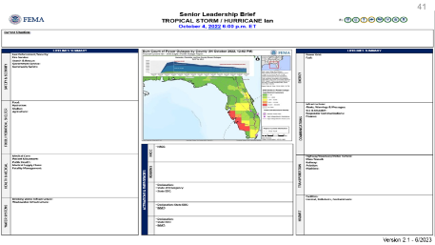 | - This slide depicts an up-to-date example of a Tier I: Senior Leadership Brief which factors in the new Water Systems lifeline as well as the updated Food, Hydration, Shelter lifeline.
34 | Tier II: Senior Leadership Brief  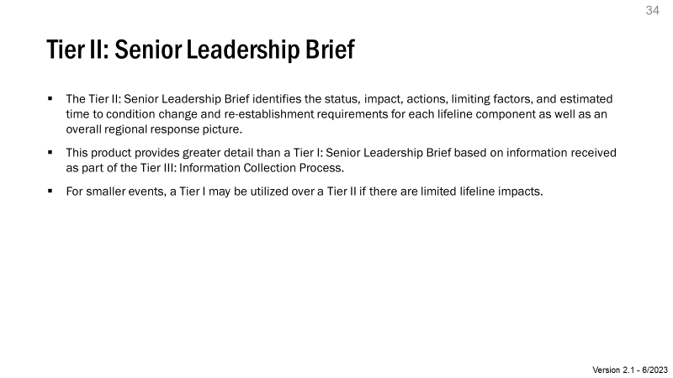 | - The Tier II: Senior Leadership Brief identifies the status, impact, actions, limiting factors, and estimated time to condition change and re-establishment requirements for each lifeline component as well as an overall regional response picture.  - This product provides greater detail than a Tier I: Senior Leadership Brief based on the information received as part of the Tier III: Information Collection Process.  - For smaller events, a Tier I may be utilized over a Tier II if there are limited lifeline impacts.
35 | Tier III: Information Collection Process  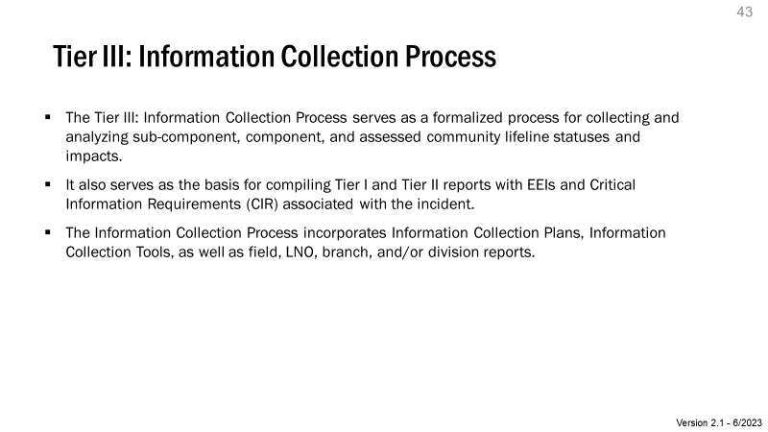 | - Tier III serves as formalized information collection process for collecting and analyzing sub-component, component, and assessed community lifeline statuses and impacts.  - It also serves as the basis for compiling Tier I and Tier II reports with essential elements of information (EEI) and critical information requirements (CIR) associated with the incident.
36 | Information Collection Process: Visualization Tools  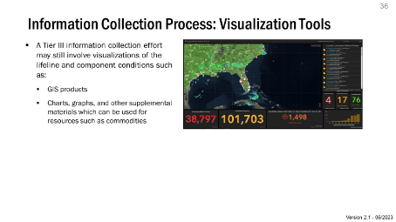 | - A Tier III information collection effort may still involve visualizations of the lifeline and component conditions such as:  - Geographical Information System (GIS) products  - Charts, graphs, and other supplemental materials which can be used for resources such as commodities
Section III: Lifelines and Operational Planning
37 | Section III:  Lifelines and Operational Planning  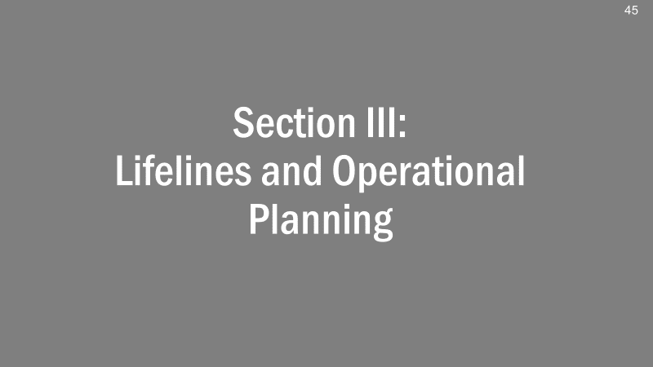 | - This section provides an overview of lifelines and operational planning at FEMA.
38 | Lifelines Drive Response and Enable Recovery Transition  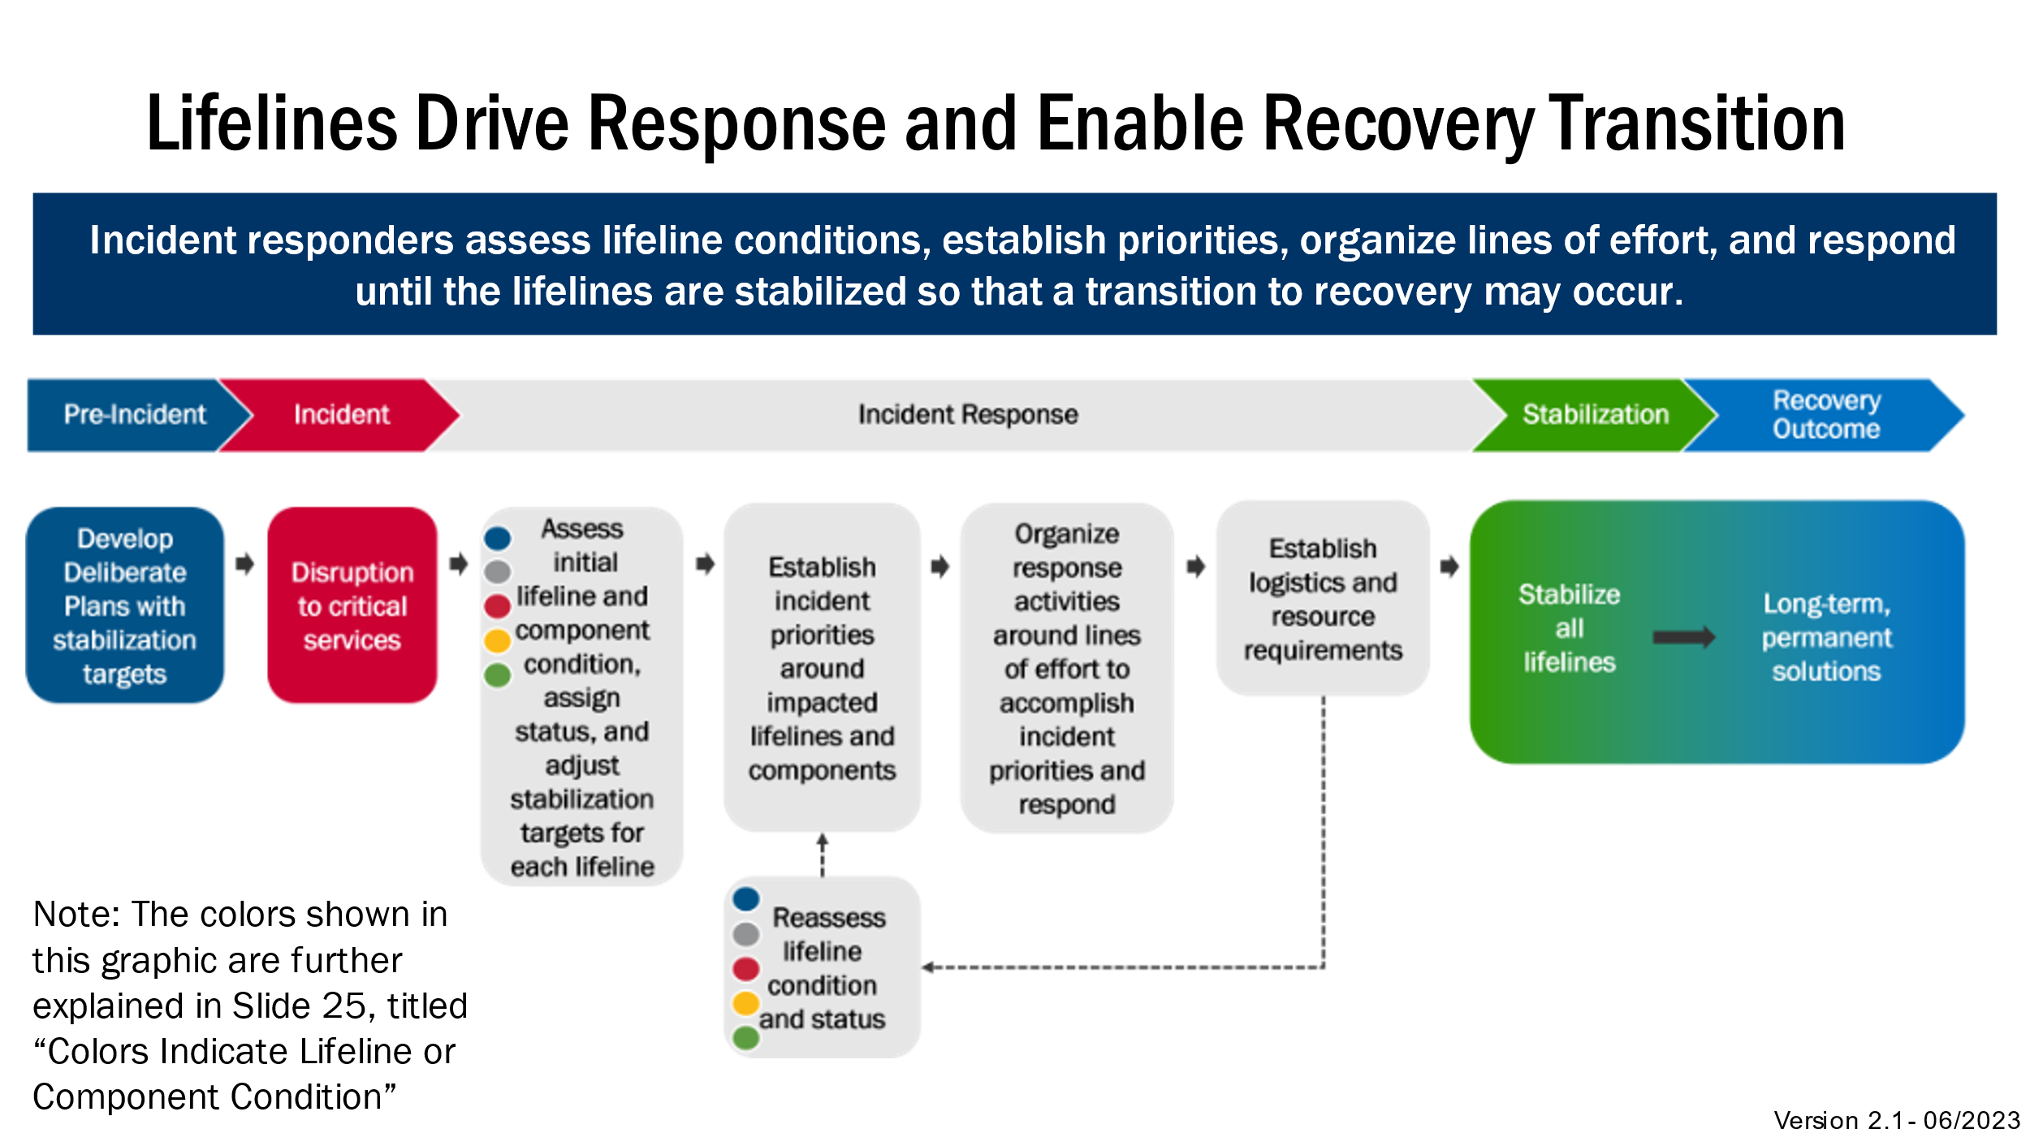 | - The graphic shows how the lifeline construct is used prior to an incident all the way through stabilization. Below is a step-by-step explanation:  - Pre-Incident  - Planners should introduce stabilization targets into deliberate planning products. As will be discussed shortly, stabilization targets indicate the result response actions should achieve to transition to recovery. The development of these targets should be a collaborative process that includes a broad group of stakeholders.  - Incident  - An incident occurs that impacts a jurisdiction(s) and disrupts critical services.  - Incident Response  - Responders assess the impacts and modify stabilization targets from the deliberate plans to develop initial incident priorities.  - Based on the incident priorities, responders actively engage in lines of effort (e.g., search and rescue) to accomplish incident priorities and respond and identify additional logistics and resource requirements.  - Response personnel continually reassess lifeline condition to refine incident priorities and active lines of effort (traditional operational period cycle) until all lifelines are stabilized, allowing for a transition to recovery.  - Stabilization  - Response transitions into recovery as operations change focus from stabilization to recovery outcomes (i.e., from restoring critical services to restoring infrastructure).  - Note: Recovery operations will likely begin prior to the stabilization.  - Note: Stabilization targets are an important aspect of response operations and a goal of FEMA’s efforts. As such, stabilization targets are a benchmark in addressing community impact to a lifeline.  - As this document does not cover recovery, recovery outcomes are not completely covered in this toolkit.
39 | Response Planning and Incident Stabilization  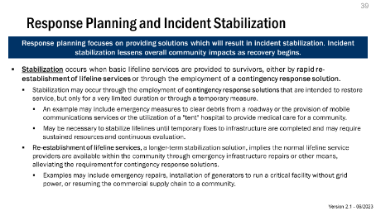 | - A goal of incident response is to stabilize lifelines. Stabilization can occur either through rapid re-establishment of the lifelines within a community or through contingency response solution.  - Responders—including all stakeholders—should set stabilization targets that answer the question “what does success look like?”  - Note: Lifeline stabilization is dynamic and may require continuous evaluation; just because a lifeline is stable does not indicate responders can “forget about” that lifeline.  - An alternate example of stabilization vice restoration if necessary:  - Scenario: An incident destroys the cell towers in an area disrupting communications.  - Contingency Response Solution: Cell on Wheels employed to provide cell service to the community Re-establishment: Emergency repairs re-establish cell service from the fixed cell towers in the community.
40 | Lifeline Stabilization Targets (1 of 2)  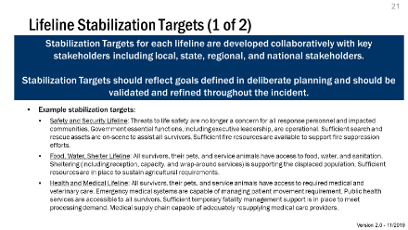 | - Stabilization Targets for each lifeline are developed collaboratively with key stakeholders including local, state, regional, and national stakeholders.  - Stabilization targets should reflect goals defined in deliberate planning and should be validated and refined throughout the incident.  - These general stabilization targets should be used as a starting point during deliberate and crisis action planning, and can be refined as needed to meet the needs of the particular scenario or incident.
41 | Lifeline Stabilization Targets (2 of 2)  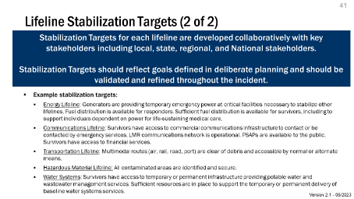 | - Stabilization Targets for each lifeline are developed collaboratively with key stakeholders including local, state, regional, and national stakeholders.  - Stabilization targets should reflect goals defined in deliberate planning and should be validated and refined throughout the incident.  - These general stabilization targets should be used as a starting point during deliberate and crisis action planning, and can be refined as needed to meet the needs of the particular scenario or incident.
42 | Community Lifelines and Response Planning  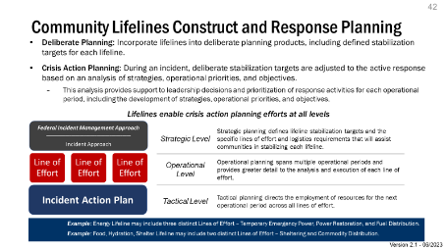 | - This section covers lifeline application in operational planning for response, both deliberate and crisis action planning.
43 | Deliberate Planning  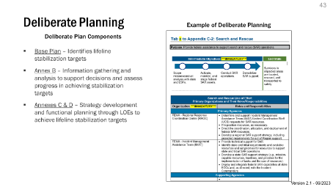 | - Lifelines are being incorporated in FEMA’s standardized response deliberate planning templates as follows:  - Base Plan – Identifies lifeline stabilization targets  - Annex B – Information gathering and analysis to support decisions and to assess progress in achieving stabilization targets  - Annexes C & D – Strategy development and functional planning through Lines of Effort (LOE) to achieve lifeline stabilization targets
44 | Deliberate Planning and All-Hazards Plan Updates  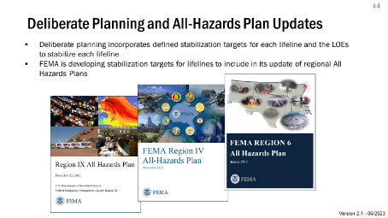 | - FEMA is consistently updating all its Regional All-Hazards plans.  - As part of this process, planners are developing stabilization targets for each lifeline and/or component based on the disaster profile and/or historical context within that region.  - As previously noted, these stabilization targets will be developed in coordination with relevant State, local, and Federal partners.
45 | Crisis Action Planning – Products and Relationships  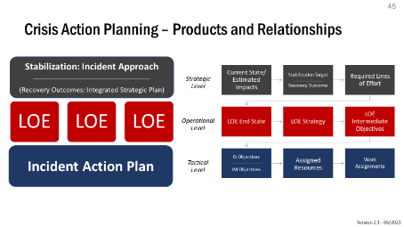 | - Crisis action planning is broken down into three levels:  - Strategic Level Planning: Overall strategy to achieve stabilization target.  - Operational Level Planning: Plan to conduct each line of effort required to achieve stabilization.  - Tactical Level Planning: Traditional IAP process, identifying objectives and work assignments for this operational period.
46 | Crisis Action Planning - Strategic  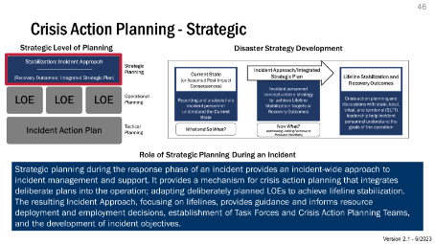 | - Strategic: Based on the current/estimated impacts, what LOEs are necessary to achieve lifeline stabilization
47 | Current v. End States & Goal Setting  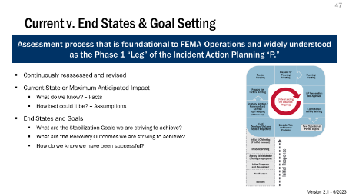 | - Assessment process that is foundational to FEMA Operations and widely understood as Phase 1 “Leg” of the Incident Action Planning P  - Continuously reassessed and iteratively revised  - Current State or Maximum Anticipated Impact  - What do we know? – Facts  - How bad could it be? - Assumptions  - End States and Goals  - What are the Stabilization Goals we are striving to achieve?  - What are the Recovery Outcomes we are striving to achieve?  - How do we know we have been successful?
48 | Lifeline Stabilization Problem Frame  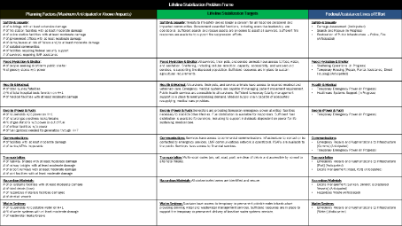 | - This template assesses the strategy to stabilize each lifeline. The left column identifies the current or anticipated impacts to each lifeline. The middle column identifies the stabilization targets. The right column identifies the required line of effort to achieve those stabilization targets.
49 | Crisis Action Planning - Operational  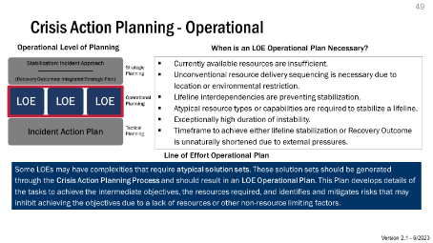 | - Operational: For each line of effort (e.g. route clearance, healthcare systems support, shelter operations), how do we activate, mobilize, employ, and demobilize that capability?
50 | Defining Lines of Effort  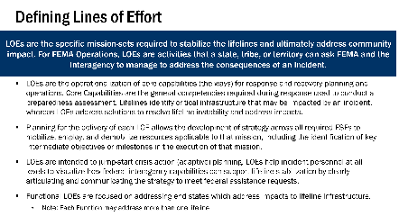 | - LOEs are the specific mission-sets required to stabilize the lifelines and address community impact. For FEMA Operations, LOEs are activities that a state, tribe, or territory can ask FEMA and the interagency to manage to address the consequences of an incident.  - Written LOEs articulate strategy by sequencing Intermediate Objectives for inclusion into the Incident Action Planning cycle (e.g., milestones), and identify resources needed to reach a desired end-state where federal assistance for that function is no longer required.
51 | Lines of Effort  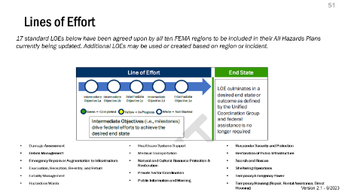 | - 17 standard Lines of Effort below have been agreed upon by all ten FEMA Regions to be included in their All Hazards Plans currently being updated. Additional Lines of Effort may be created based on region or incident.  - ESFs and FEMA programs are responsible for one or more LOEs. A single lifeline may require multiple LOEs to achieve stabilization. Conversely, a single LOE may support the stabilization of multiple lifelines.
52 | Example: Healthcare Systems Support LOE  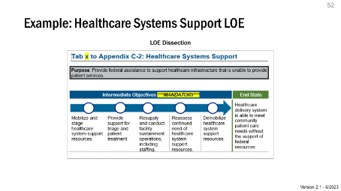 | - This slide shows an example of the Healthcare Systems Support LOE, with the following intermediate objectives to achieve the LOE end-state of “Healthcare delivery system is able to meet community patient care needs without the support of federal resources”  - Mobilize and stage healthcare system support resources  - Provide support for triage and patient movement  - Resupply and conduct facility sustainment operations  - Reassess continued need of healthcare system support resources  - Demobilize healthcare system support resources
53 | Phasing  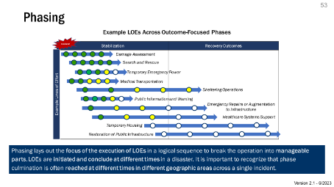 | - Phasing lays out the focus of the execution of LOEs in a logical sequence to break the operation into manageable parts.  - LOEs are initiated and conclude at different times in a disaster.  - It is important to recognize that phase culmination is often reached at different times in different geographic areas across a single incident.
54 | Crisis Action Planning – National/Regional Support Plan (N/RSP)  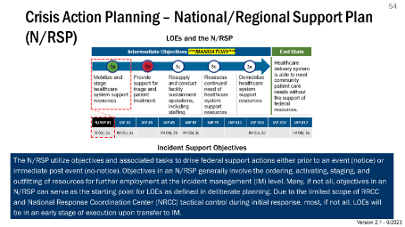 | - The N/RSP utilize objectives and associated tasks to drive federal support actions either prior to an event (notice) or immediate post event (no-notice).  - Objectives in an N/RSP generally involve the ordering, activating, staging, and outfitting of resources for further employment at the IM level.  - Many, if not all, objectives in an N/RSP can serve as the starting point for LOEs as defined in deliberate planning.  - Due to the limited scope of RRCC and NRCC tactical control during initial response, most, if not all LOEs will be in an early stage of execution upon transfer to IM.
55 | Crisis Action Planning - Tactical  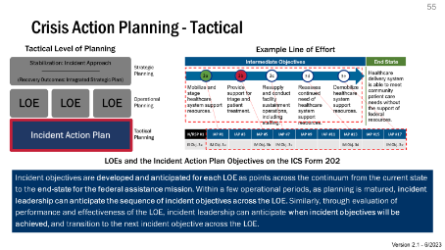 | - Tactical: The traditional IAP process can be informed by strategic/operational planning and intermediate objectives for each LOE  - Incident objectives are developed and anticipated for each LOE as points across the continuum from the current state to the end-state for the federal assistance mission.  - Within a few operational periods, as planning is matured, incident leadership can anticipate the sequence of incident objectives across the LOE.  - Similarly, through evaluation of performance and effectiveness of the LOE, incident leadership can anticipate when incident objectives will be achieved, and transition to the next incident objective across the LOE.
56 | IAP Incident Objectives  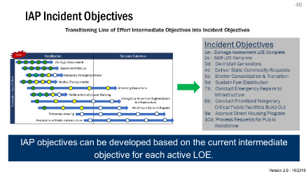 | - Looking at the current intermediate objective for each active LOE can directly inform the development of IAP objectives
57 | Transition to Integrated Strategic Planning  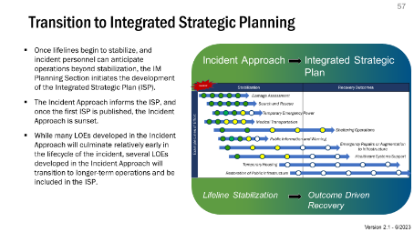 | - Once lifelines begin to stabilize, and incident personnel can anticipate operations beyond stabilization, the IM Planning Section initiates the development of the Integrated Strategic Plan (ISP).  - The Incident Approach informs the ISP, and once the first ISP is published, the Incident Approach is sunset.  - While many LOEs developed in the Incident Approach will culminate relatively early in the lifecycle of the incident, several LOEs developed in the Incident Approach will transition to longer-term operations and be included in the ISP.
58 | Recovery Outcomes  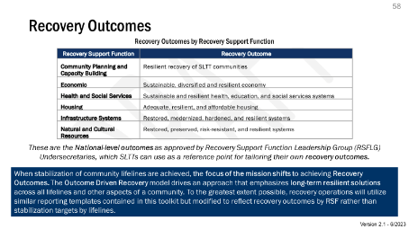 | - When stabilization of Community Lifelines is achieved, the focus of the mission shifts to achieving Recovery Outcomes.  - The Outcome Driven Recovery model drives an approach that emphasizes long-term resilient solutions.
Section IV: Icons and Templates
59 | Section IV:  Icons and Templates   | - This section covers all current lifeline iconography (including accepted colors and formats) as well as relevant templates.  - Detailed explanations on the templates can be found within the template files.
60 | Templates  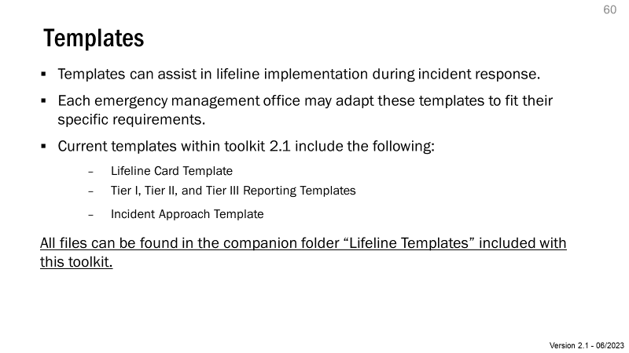 | - The templates listed on the slide are currently in use at FEMA in varying capacities.  - Each emergency management office or partner may adapt these templates to fit their specific requirements.  - As more templates are developed, they will be added to the Toolkit for further dissemination.
61 | Guidance for Using Lifeline Icons  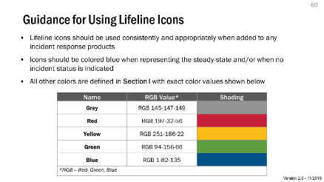 | - The color palette provided on the slide is the official color condition designation for the lifelines; Red-Green-Blue (RGB) values should not be altered.
62 | Editing Lifeline Icons  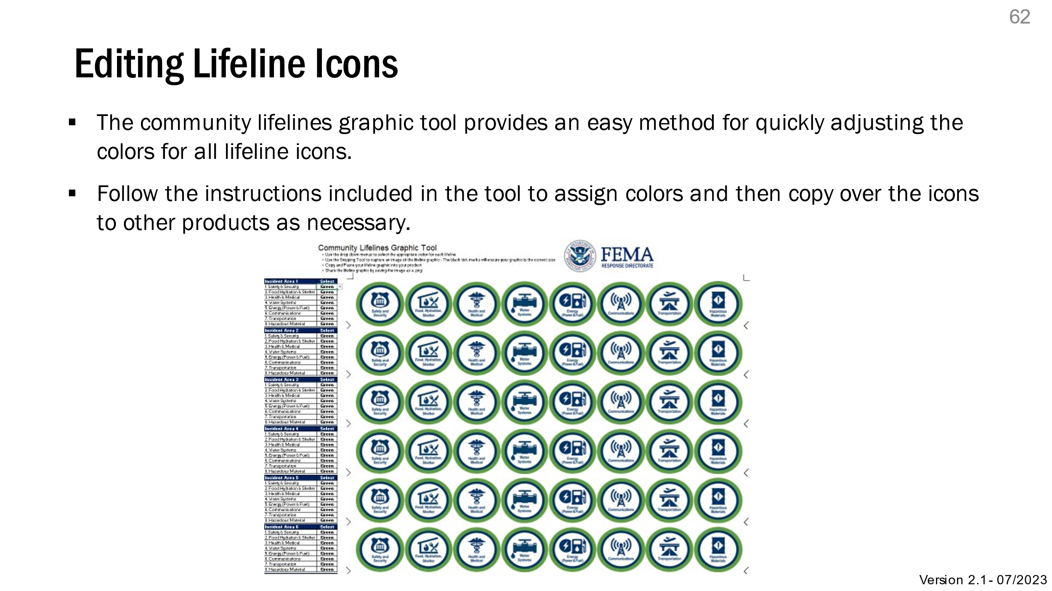 | - An easy-to-use tool is provided with this toolkit to adjust lifeline icon colors for reporting, maintaining spacing and alignment of the icons.
63 | Icon Library (1 of 2)  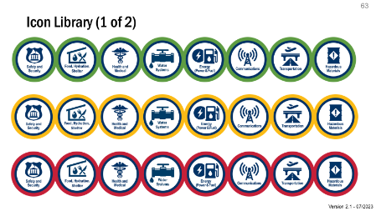 | - These slides provide the individual icon graphics
64 | Icon Library (2 of 2)  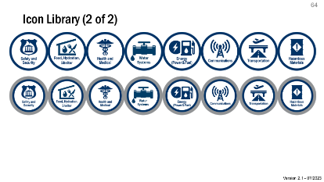 | - These slides provide the individual icon graphics
65 | Your Feedback Matters  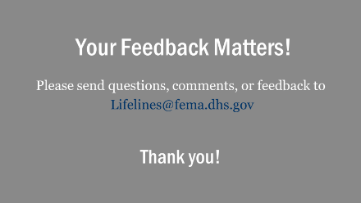 | - As mentioned earlier, the lifelines construct will continue to evolve and mature based on stakeholder feedback and lessons learned from operations and exercises. Please provide any feedback at lifelines@fema.dhs.gov.
66 | [End Slide]   | - Thank you or your time today. I will now take any questions and open it up for discussion.

