DEPARTMENT OF HOMELAND SECURITY - Federal Emergency Management Agency  Application form for single Residential lot or structure amendments to national flood insurance program maps | O.M.B. NO. 1660-0015  Expires February 28, 2014

PAPERWORK BURDEN DISCLOSURE NOTICE
Public reporting burden for this data collection is estimated to average 2.4 hours per response. The burden estimate includes the time for reviewing instructions, searching existing data sources, gathering and maintaining the data needed, and completing and submitting this form. This collection of information is required to obtain or retain benefits. You are not required to respond to this collection of information unless a valid OMB control number is displayed on this form. Send comments regarding the accuracy of the burden estimate and any suggestions for reducing the burden to: Information Collections Management, Department of Homeland Security, Federal Emergency Management Agency, 1800 South Bell Street, Arlington, VA 20598-3005, Paperwork Reduction Project (1660-0015) NOTE: Do not send your completed form to this address.
This form should be used to request that the Department of Homeland Security’s Federal Emergency Management Agency (FEMA) remove a single structure or legally recorded parcel of land or portion thereof, described by metes and bounds, certified by a registered professional engineer or licensed land surveyor, from a designated Special Flood Hazard Area (SFHA), an area that would be inundated by the flood having a 1%-chance of being equaled or exceeded in any given year (base flood), via Letter of Map Amendment (LOMA). It shall not be used for requests submitted by developers, for requests involving multiple structures or lots, for property in alluvial fan areas, for property located within the regulatory floodway, or requests involving the placement of fill. (NOTE: Use MT-1 forms for such requests). Fill is defined as material from any source (including the subject property) placed that raises the grade to or above the Base Flood Elevation (BFE). The common construction practice of removing unsuitable existing material (topsoil) and backfilling with select structural material is not considered the placement of fill if the practice does not alter the existing (natural grade) elevation, which is at or above the BFE. Also, fill that is placed before the date of the first National Flood Insurance Program (NFIP) map showing the area in an SFHA is considered natural grade.
LOMA: | A letter from DHS-FEMA stating that an existing structure or parcel of land that has not been elevated by fill would not be inundated by the base flood.
A – This section may be completed by the property owner or by the property owner’s agent. In order to process your request, all information on this form must be completed in its entirety, unless stated as optional. Incomplete submissions will result in processing delays.

- Has fill been placed on your property to raise ground that was previously below the BFE?
No Yes – If Yes, STOP!! – You must complete the MT-1 application forms; visit
http://www.fema.gov/plan/prevent/fhm/dl_mt-1.shtm
or call the FEMA Map Information eXchange toll free: (877-FEMA MAP) (877-336-2627)

- Legal description of Property (Lot, Block, Subdivision or abbreviated description from the Deed) and street address of the Property (required):

3. Are you requesting that a flood zone determination be completed for (check one):
A structure on your property? What is the date of construction? _______________ (MM/YYYY)
A portion of your legally recorded property? (A certified metes and bounds description and map of the area to be removed, certified by a registered professional engineer or licensed land surveyor, are required. For the preferred format of metes and bounds descriptions, please refer to the MT-EZ Instructions.)
Your entire legally recorded property?

All documents submitted in support of this request are correct to the best of my knowledge. I understand that any false statement may be punishable by fine or imprisonment under Title 18 of the United States Code, Section 1001.
Applicant’s Name (required): |  | E-mail address (optional) ( By checking here you may receive correspondence electronically at the email address provided):
Mailing Address (include Company name if applicable) (required): |  | Daytime Telephone No. (required):
 |  | Fax No. (optional):
Signature of Applicant (required) |  |  | Date (required)
End of Section A

B – This section must be completed by a registered professional engineer or licensed land surveyor. Incomplete submissions will result in processing delays.
NOTE: If the request is to have a flood zone determination completed for the structure, and an Elevation Certificate has been completed for this property, it may be submitted in lieu of Section B. If the request is to have a flood zone determination completed for the entire legally recorded property, or a portion thereof, the lowest elevation on the lot or described portion must be provided in Section B.

Applicable Regulations
The regulations pertaining to LOMAs are presented in the National Flood Insurance Program (NFIP) regulations under Title 44, Chapter I, Parts 70 and 72, Code of Federal Regulations. The purpose of Part 70 is to provide an administrative procedure whereby DHS-FEMA will review information submitted by an owner or lessee of property who believes that his or her property has been inadvertently included in a designated SFHA. The necessity of Part 70 is due in part to the technical difficulty of accurately delineating the SFHA boundary on an NFIP map. Part 70 procedures shall not apply if the topography has been altered to raise the original ground to or above the BFE since the effective date of the first NFIP map [e.g., a Flood Insurance Rate Map (FIRM) or Flood Hazard Boundary Map (FHBM)] showing the property to be within the SFHA.

Basis of Determination
DHS-FEMA’s determination as to whether a structure or legally recorded parcel of land, or portion thereof, described by metes and bounds, may be removed from the SFHA will be based upon a comparison of the Base (1%-annual-chance) Flood Elevation (BFE) with certain elevation information. The elevation information required is dependent upon what is to be removed from the SFHA. For Zones A and AO, please refer to Page 7 of the MT-EZ Form Instructions for information regarding BFE development in those areas and supporting data requirements.
Determination Requested For: (check one) |  |  | Elevation Information Required: (complete Item 5)
Structure located on natural grade (LOMA) |  |  | Lowest Adjacent Grade to the structure (the elevation of the lowest ground touching the structure including attached patios, stairs, deck supports or garages)
Legally recorded parcel of land, or portion thereof (LOMA) |  |  | Elevation of the lowest ground on the parcel or within the portion of land to be removed from the SFHA
1. PROPERTY INFORMATION
Property Description (Lot and Block Number, Tax Parcel Number, or Abbreviated Description from the Deed, etc.):
2. STRUCTURE Information
Street Address (including Apt. Unit, Suite, and/or Bldg. No.):

What is the type of construction? (check one) crawl space slab on grade basement/enclosure
other (explain):
3. GEOGRAPHIC COORDINATE DATA
Please provide the Latitude and Longitude of the most upstream edge of the structure (in decimal degrees to nearest fifth decimal place)
Indicate Datum: WGS84 NAD83 NAD27 Lat. . Long. .
Please provide the Latitude and Longitude of the most upstream edge of the property (in decimal degrees to nearest fifth decimal place)
Indicate Datum: WGS84 NAD83 NAD27 Lat. . Long. .
4. FLOOD INSURANCE RATE MAP (FIRM) INFORMATION
NFIP Community Number: | Map Panel Number: |  |  | Base Flood Elevation (BFE): |  | Source of BFE:
5. elevation information (survey required)
- Lowest Adjacent Grade (LAG) to the structure (to the nearest 0.1 foot or meter) . ft. (m)
- Elevation of the lowest grade on the property; or within metes and bounds area (to the nearest 0.1 foot or meter) . ft. (m)
- Indicate the datum (if different from NGVD 29 or NAVD 88 attach datum conversion) NGVD 29 NAVD 88 Other (add attachment)
- Has FEMA identified this area as subject to land subsidence or uplift? No Yes (provide date of current releveling):

This certification is to be signed and sealed by a licensed land surveyor, registered professional engineer, or architect authorized by law to certify elevation information. All documents submitted in support of this request are correct to the best of my knowledge. I understand that any false statement may be punishable by fine or imprisonment under Title 18 of the United States Code, Section 1001.
Certifier’s Name: |  | License No.: |  |  | Expiration Date: |  | Seal (optional)
Company Name: |  | Telephone No.: |  |  | Fax No.: |  | Seal (optional)
Email: |  |  |  |  |  |  | Seal (optional)
Signature: |  |  |  |  | Date: |  | Seal (optional)

In addition to this form (MT-EZ), please complete the checklist below. ALL requests must include one copy of the following:

Copy of the effective FIRM panel on which the structure and/or property location has been accurately plotted

Copy of the Subdivision Plat Map (with recordation data and stamp of the Recorder’s Office)
OR
Copy of the Property Deed (with recordation data and stamp of the Recorder’s Office), accompanied by a tax assessor’s map or other certified map showing the surveyed location of the property relative to local streets and watercourses. The map should include at least one street intersection that is shown on the FIRM panel.

Please include a map scale and North arrow on all maps submitted.

Please do not submit original documents. Please retain a copy of all submitted documents for your records.

DHS-FEMA encourages the submission of all required data in a digital format (e.g. scanned documents and images on Compact Disc [CD]). Digital submissions help to further DHS-FEMA’s Digital Vision and also may facilitate the processing of your request.

Incomplete submissions will result in processing delays. For additional information regarding this form, including where to obtain the supporting documents listed above, please refer to the MT-EZ Form Instructions located at
http://www.fema.gov/plan/prevent/fhm/dl_mt-ez.shtm.
Mail your request to:
LOMC Clearinghouse
847 SOUTH PICKETT STREET
ALEXANDRIA, VA 22304-4605
Attn.: loma Manager

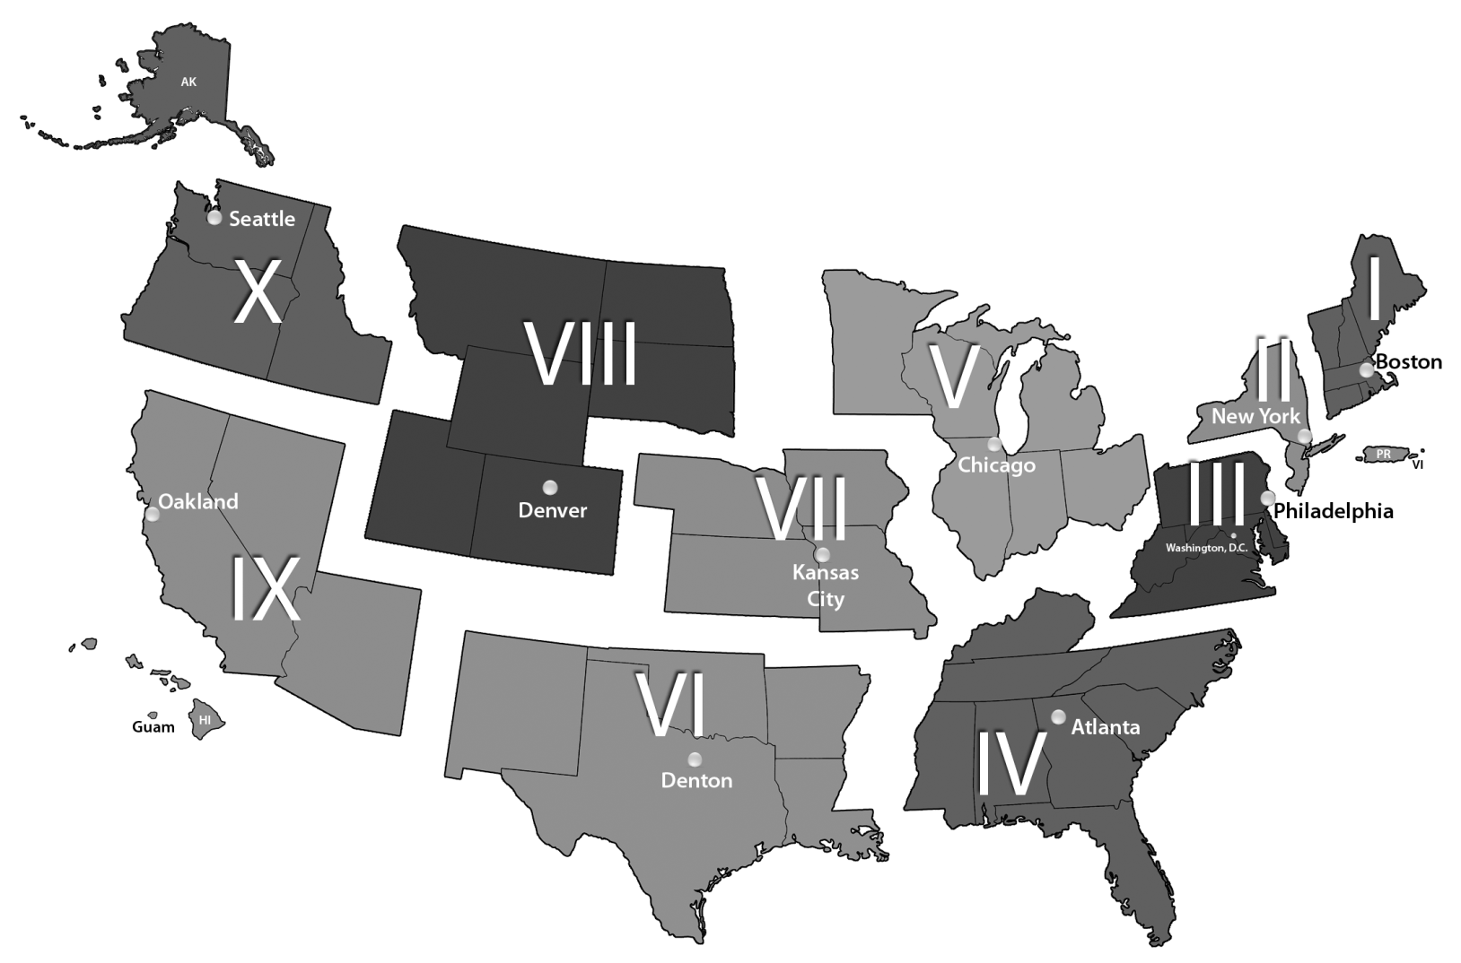
FEMA REGIONS

